Pokhara University

Level: Bachelor | Semester – Spring | Year : 2009
Programme: BE |  | Full Marks : 100
 |  | Pass Mark : 45
Course: Basic Electrical Engineering |  | Time : 3 hrs

Candidates are required to give their answers in their own words as far as practicable.
The figures in the margin indicate full marks.

Attempt all the questions.

1. | - State Kirchhoff's laws. Use Maxwell's mesh analysis to find current through 10Ω resistance in the network shown below.  - Determine the current flowing in 2Ω resistor by Thevenin's theorem. | 8  7
2. | - State Super-position theorem. Apply this theorem to find magnitude and direction of current through 20Ω resistor.  - Calculate the average and effective values of the square voltage wave shown in figure below.  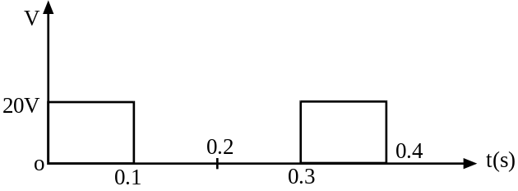 | 8  7
3. | - In the circuit given below, total current i = (20+j0) A. Calculate (i) branch current i₁ and i₂ (ii) voltage V₁, V₂ and V. (iii) power factor of entire circuit. (iv)Active and reactive powers in the entire circuit. (v) Draw the phasor diagram.  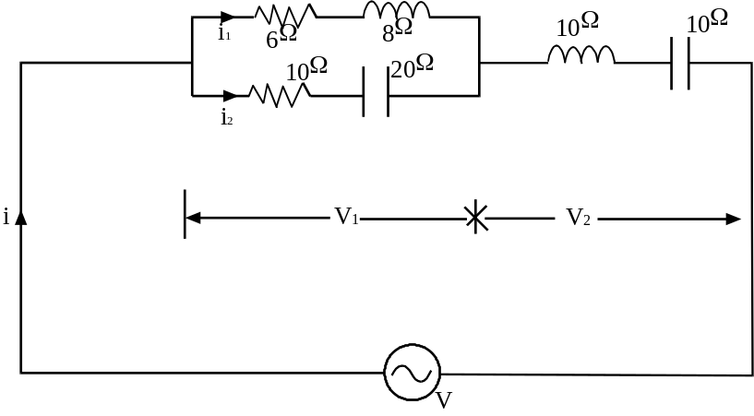  - Explain the voltage resonance in RLC series circuit with necessary derivations and resonance curve. | 8  7
4. | - Three equal impedance each (30+j40) Ω are connected in star and a balanced three phase 400V supply system is connected across this load. Find (i) the current flowing through the load, (ii) the power consumed in each phase and (iii) the power factor of the load.  - Explain the power measurement of three phases by two wattmeter method. | 8  7
5. | - A 10 kva, 200/400 V, 50-Hz, 1-phase transformer gives the following test results;  O.C. test (HV side open): 200V, 103A, 120W.  S:C. test (LV side shorted): 22V, 30A, 200W.  Find the parameters of equivalent circuit as referred to LV side.  - Explain the working principle of single phase energy meter. | 8  7
6. | - List out the different speed control methods used in DC motors and explain the flux control method of dc series motor.  - A 220V shunt motor runs at 1450 RPM of full load with an armature current of 11 A. The total resistance of the armature and brushes is 0.6 ohm. If the speed is to be reduced to 1000 RPM with the same armature current, calculate the value of resistance to be connected in series with the armature. | 8  7
7. | Write short notes on (Any Two):  - Three phase induction motor  - Analogy of magnetic circuits with electric circuit  - Hysteresis and eddy current loss | 2×5

